
Science Department
Year 12 2015
Topic Test 3: Organics

Name: _____________________________

Teacher: ____________________

Instructions to Students:

1. 50 minutes permitted
2. Attempt all questions
3. Write in the spaces provided
4. Show all working when required
5. All answers to be in blue or black pen, diagrams in pencil.

Part A |  | Part B |  |  | TOTAL |  | Final Percentage
/15 |  | /40 |  |  | / 55
Section One: Multiple-choice (15 questions) (15 marks)

This section has 15 questions. Answer all questions on the separate Multiple-choice Answer Sheet provided.

- Which of the following molecules contains at least a single bond, a double bond
and a triple bond?

- CH₂CHCCH
- CH₂Cl(CH₂)₃CH₃
- CH₂CClCClCH₂
- CH₃CHBrCH₃

- Which one of the following names is incorrect?

- 1,2,3-trimethylcyclohexane.
- 2,3,3-trichlorohexane.
- 2,3,4-trichlorocyclohexene.
- 4,4,5-trimethylhexane.

- Which of the following compounds has only one distinct form of the molecule
which can be drawn?

- 3-chloropropene.
- Dichloropropanone.
- Butene
- 1,2-dichloropropene.

- Which one of the following substances will exhibit geometrical (cis - trans)
isomerism?

- CH₃CCl=CCl₂
- CH₃-(CH₂)₂-CH=CHCOOH
- CH₂=CH-(CH₂)₄-CH₃
- HOOC-(CH₂)₂-COOH

5. Which of the following molecules is the trans form of a pair of geometric isomers?
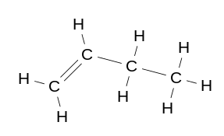

a)

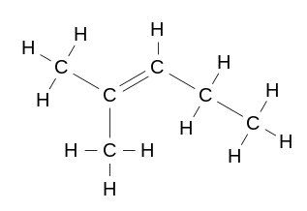
b)

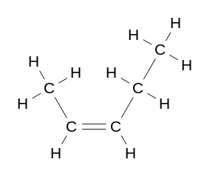
c)

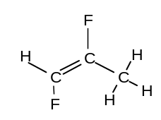 d)

- Which of the following reactions are substitution reactions?

I C₂H₂ + HCl → CH₂CHCl
II CH₄ + Cl₂ → CH₃Cl + HCl
III CH₃CH₃ + 2Br₂ → CH₂BrCH₂Br + 2HBr
IV CH₄ + O₂ → CO₂ + H₂O

- II and IV only.
- II and III only.
- I and IVonly.
- I and II only.

- One of the compounds formed when fluorine reacts with ethane is 1,2-difluoroethane.
This type of reaction is called:

- an addition reaction.
- a hydrolysis reaction.
- a combustion reaction.
- a substitution reaction.

- Which of the following has been filled in correctly?

 |  | Representation of functional group | Main intermolecular forces between molecules of the substance | Solubility
a) | Carboxylic acid | RCOOH | dipole - dipole | soluble in water
b) | Amine | RNH₂ | hydrogen bonding | soluble in water
c) | Aldehyde | RCHO | hydrogen bonding | soluble in water
d) | Alkene | R = R | dispersion forces | soluble in water

- 2-pentanone can be prepared from which of the following lists of substances?

- 2-pentanoic acid and 2-pentanol.
- 2-pentanol and acidified potassium permanganate solution.
- Pentanal and acidified potassium permanganate solution.
- 2-pentene and pentanoic acid.

- The figure below shows the structure of aspirin. The structure contains:
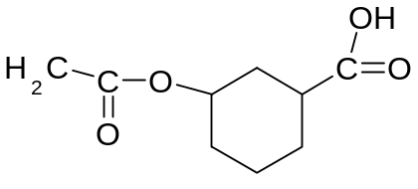

- an acid and an ester
- an acid and a ketone
- an ester and a ketone
- a ketone and an alcohol
- Which of the following lists do not have the compounds arranged in order of
decreasing boiling point?

- Pentanal, 1-pentanol, 1-pentanoic acid.
- Butanoic acid, butanone, butane.
- Hexane, pentane, propane.
- Diamond, ammonia, carbon dioxide.

- Which of the following substances will react with CH₃(CH₂)₂COOH to produce CH₃(CH₂)₂COOCH₂CH₃ and water?

- CH₃CH₂CH₃
- CH₃CHCH₂
- Acidified potassium permanganate solution
- CH₃CH₂OH

- Which of the following most correctly describes what happens in the manufacture of soaps?

 | Main reaction classification | Reactants | By-product(s)
a) | Hydrolysis | triglyceride, water | glycerol
b) | Saponification | sodium hydroxide, fat | 1,2,3-propanetriol
c) | Esterification | glycerol, fatty acids | water
d) | Sulfonation | sulfuric acid, alkyl benzene | water

- Which of the following is an isomer of fumaric acid, whose structure is shown below?

HOOC H
C = C

H COOH

- CH₃CH₂CH₂COOH
- HO(CH₂)₃ COOH
- HOOCCH₂CHOHCOOH
- HOOC(CH)₂COOH

- The following represents the repeating sequence of a condensation polymer:

-OCCH₂COO(CH₂)₂O-

Which of the following represents the pairs of monomers which produced
the above polymer?

- CH₂OH and HOOC(CH₂)₂COOH
- HOOCCH₂COOH and HO(CH₂)₂OH
- HOCH₂OH and HOOC(CH₂)OH
- (HO)₂CCH(OH)₂ and (HOOC)₂CH₂(COOH)₂
PART B: SHORT ANSWER QUESTIONS (40 MARKS)

- The hydrocarbon but-1-ene (C₄H₈) is a member of the homologous series of alkenes.

- Provide the general formula of the alkenes: …………………………… (1)

- But-1-ene has structural isomers.
- State the meaning of the term structural isomers.

...............................................................................................................
...............................................................................................................
...............................................................................................................
.............................................................................................................. (2)

- Give the IUPAC names of two further isomers of C₄H₈.

...............................................................................................................
.............................................................................................................. (2)

- Write an equation for the combustion of But-1-ene in an excess of air.
.............................................................................................................. (1)

- Write IUPAC names for the following compounds.

Compounds | Names
CH₃CH₂COOCH₃
(CH₃)₃CH
CH₃CH(CH₃)CH₂CH₂COCH₃

(3)

- From the following list of substances, chose two that fit the descriptions below.

H₃PO₄ Cr(NO₃)₃ Cl₂ HNO₃ CH₃CH₂CH₂COOH

Cr(OH)₃ K₂Cr₂O₇ C₂H₄ Br₂ CH₃CHO

C₃H₈ CH₃CH₂OH H₂ CH₄ HOOCCOOH

Description | Substance 1 | Substance 2
Two green substances that are both soluble in water.
Two monoprotic acids.
Two substances that can react together to produce ethanoic acid
Two substances that can be used as monomers in polymerization reactions
Two substances with the same empirical formula.

(5)
- A student has been asked to prepare a sample of propyl ethanoate.

- Name three substances necessary for the laboratory preparation of
the above compound.

……………………………………………………….
……………………………………………………….
………………………………………………………. (3)

- Draw the structure of propylethanoate: (1)
(1(

- Name two isomers of the above substance. (2)
……………………………………………………….
……………………………………………………….

- Write an equation for the formation of propylethanoate: (1)

………………………………………………………………………………
………………………………………………………………………………

- The sodium salt of stearic acid is used as soap.

- Write an equation for the production of the soap Sodium Stearate,
(CH₃(CH₂)₁₆COONa) from a triglyceride and sodium hydroxide.

(2)

- What are the terms used to describe the two portions of the soap
molecule A (shaded) and B (unshaded) in regards to their interaction
with water? (2)

(CH₃(CH₂)₁₆COONa)

A B

A: ………………………………………………………………………

B: ………………………………………………………………………

- What are the intermolecular forces between portion A and a grease stain
and portion B and water? (2)

A: ........................................................................................................
B: .......................................................................................................

- The repeating units of two polymers, P and Q, are shown below.

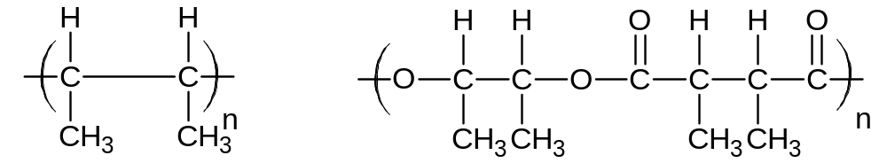
P Q
- Draw the structure of the monomer used to form polymer P. Name the type of polymerisation involved.
Structure of monomer

Name of monomer: ………………………………………………….
Type of polymerisation ............................................................ (3)

- Draw the structures of two compounds which react together to form polymer Q. Name these two compounds and name the type of polymerisation involved.
Structure of compound 1

Structure of compound 2

Type of polymerisation ................................................................... (3)

- Alanine and aspartic acid are naturally occurring amino acids.
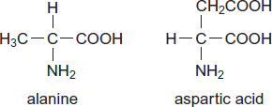
- Draw the structure of the zwitterion formed by alanine.

(1)

- Draw the structure of a dipeptide formed by two aspartic acid molecules.

(1)

- The polymer commonly known as Kevlar is used to make bullet proof vests and bicycle tyres. It can be made in a polymerization reaction between the two monomers shown below.

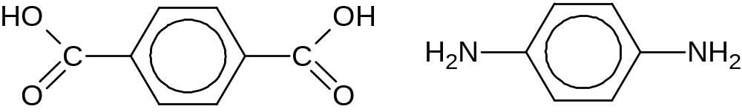

- Draw one repeating unit of the polymer.

- Indicate the amide linkage on your drawing. (2)
- In terms of the intermolecular forces between the polymer chains, explain the strength of Kevlar fibres. Use a diagram in your answer.
.............................................................................................................
.............................................................................................................
.............................................................................................................
.............................................................................................................
.............................................................................................................
.............................................................................................................
.............................................................................................................
.............................................................................................................
.............................................................................................................
.............................................................................................................
.............................................................................................................
............................................................................................................. (3)

END OT TEST

